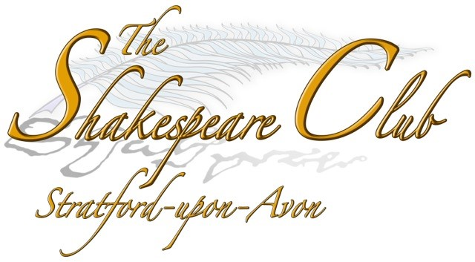
Membership Application Form

Annual membership £18 per person
Students no charge

Name(s) _____________________________________________

Address _____________________________________________

Post Code _____________________________________________

Telephone No. __________________________________________

Email Address __________________________________________

Payment in cash ____ by cheque___ by BACS ___

Note: Only print off page 1 of this document.

Either
BRING the completed form and payment with you to a Club meeting.
or
POST:
1. The completed form
2. Cheque payable to The Shakespeare Club
3. Optional stamped addressed envelope to receive your membership card in the post, or collect your membership card at the first meeting you attend.
to
The Treasurer
The Shakespeare Club of Stratford-upon-Avon
The Shakespeare Institute
Mason Croft, Church Street
Stratford-upon-Avon
CV37 6HP
or
EMAIL:
your completed form to stratfordshakespeareclub@gmail.com
and make a BACS payment direct to the bank account of the Shakespeare Club.
Sort code 30 98 26 Account no 02058759
with your surname as the reference.

You will receive an email confirming your payment and you can collect your membership card at the first meeting you attend.

